KENDRIYA VIDYALAYA NO.2 NHPC BANBASA
CLASS-11
SUB-BIOLOGY SET –A
TERM-1ST PAPER
Time: 90 Minutes
General Instructions:
1. The Question Paper contains three sections.
2. Section A has 24 questions. Attempt any 20 questions
3. Section B has 24 questions. Attempt any 20 questions.
4. Section C has 12 questions. Attempt any 10 questions.
5. All questions carry equal marks.
6. There is no negative marking
SECTION-A
Section – A consists of 24 questions. Attempt any 20 questions from this section. The first attempted 20 questions would be evaluated.
1. Keystone species are
(a) important for ecosystem (b) important for plants
(c) endangered species (d) extinct species
2.National Botanical Research Institute is located in
(a) Shimla (b) Dehradun (c) Howrah (d) Lucknow
3.Scientific name of plants are given by
(a) International code for Botanical nomenclature
(b) International code for biological plants
(c) Indian code for Botanical nomenclature
(d) International code for zoological nomenclature
4.Choose the correct pair.
(a) Parasitic fungi – feeds on plants and animals
(b) Saprotrophic fungi – feeds on dead and decaying organic matter
(c) Symbiotic fungi – mycorrhiza
(d) All of the above are true
5.Binomial nomenclature was given by
(a) huxley (b) ray (c) darwin (d) linnaeus
6.Which of the following is an indicator of air pollution?
(a) Mycorrhiza (b) Agaricus (c) Lichens (d) Common mushrooms
7.Rhodophyceae is called red algae because of the pigment
(a) Fucoxanthin (b) Phycoerythrin (c) Carotenoids (d) Chlorophyll c
8.In a monoecious plant
(a) Male and female sex organs are on the same individual
(b) Male and female gametes are of two morphologically distinct types
(c) Male and female sex organs are on different individuals
(d) All the stamens are fused to form one unit
9.The seedless vascular plants whose sporophytes are larger than their small and independent gametophytes are
(a) Pteridophytes (b) Angiosperms (c) Gymnosperms (d) None of these
10.Radula is found in
(a) Pila sp. (b) Chiton sp. (c) Lamellidens sp. (d) Pinctada sp.
11.Turtles are
(a) Arthropods (b) Pisces (c) Reptiles (d) Molluscs
12.Sharks, skates, and rays are also called ______ fishes.
(a) Jawless (b) Bony (c) Cartilaginous (d) Freshwater
13.
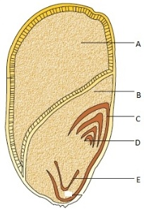
.

Label the parts of a monocot seed.
(a) A.Endosperm, B. Scutellum, C. Radicle, D. Coleoptile, E. Plumule
(b) A.Endosperm, B. Coleoptile, C. Scutellum, D. Radicle, E. Plumule
(c) A.Endosperm, B. Scutellum, C. Coleoptile, D. Radicle, E. Plumule
(d) A.Endosperm, B. Scutellum, C. Coleoptile, D. Plumule, E. Radicle
14.Which of the following is a correct pair?
(a) Cuscuta – parasite (b) Dischidia – insectivorous
(c) Opuntia – predator (d) Capsella – hydrophyte
15.Cymose inflorescences commonly occurs in
(a) Cruciferae (b) Malvaceae (c) Solanaceae (d) Liliaceae
16.Ciliated epithelium is present in
(a) fallopian tubes (b) blood vessels (c) mid brain (d) none of the above
17.Blood corpuscles are formed in the
(a) Haversian canal (b) endosteum (c) red bone marrow (d) pancreas
18.Osteoblasts are found in
(a) blood (b) muscle (c) bone (d) catrilage
19.Plasma membrane is
(a) impermeable (b) semi-permeable
(c) completely permeable (d) differentially permeable
20.Which of the following does not have cell wall?
(a) Mycoplasma (b) Bacteria (c) PPLO (d) Blue green algae
21.Insulin is made up of _______ and _______.
(a) glucose and fructose (b) glucose and fructose
(c) fructose and mannose (d) mannose and glucose
22.Enzymes increase the rate of reaction by
(a) lowering activation energy (b) increasing activation energy
(c) increasing temperature and pH (d) decreasing temperature and pH
23.Which of the following is not a pyrimidine?
(a) Uracil (b) Cytosine (c) Guanine (d) Thymine
24.Which of the following is not a polysaccharide?
(a) Lactose (b) Starch (c) Glycogen (d) Dextrin

SECTION - B
Section - B consists of 24 questions (Sl. No.25 to 48). Attempt any 20 questions from this section. The first attempted 20 questions would be evaluated.
Question No. 25 to 28 consist of two statements – Assertion (A) and Reason (R). Answer these questions selecting the appropriate option given below: A. Both A and R are true and R is the correct explanation of A B. Both A and R are true and R is not the correct explanation of A C. A is true but R is false D. both A and R is false.
25.Assertion: Arachidic acid is an unsaturated fatty acid.
Reason: There are one or more double bonds between carbon atoms in unsaturated fatty acids.
26.Assertion : Botany deals with the study of plants and zoology deals with the study of animals.
Reason : Biology is the study of living beings.
27.Assertion : Bacteria are prokaryotic.
Reason : Bacteria do not possess true nucleus and membrane bound cell organelles.
28.Assertion : Algae and fungi are grouped in thallophyta.
Reason : Algae and fungi show no differentiation in thallus.
29.
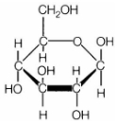The structure shown above is
(a) mannose (b) fructose (c) glucose (d) galactose
30.What is the edible part of Mango?
(a) Epicarp (b) Mesocarp (c) Endocarp (d) Thalamus
31.What is a tonoplast?
(a) Outer membrane of mitochondria
(b) Inner membrane of chloroplast
(c) Membrane boundary of the vacuole of plant cells
(d) Cell membrane of a plant cell.
32.Select the incorrect statement from the following

1) NBRI (National Botanical Research Institute) is situated at Lucknow
2) Plant families like convolvulaceae and solanaceae are included in other polynomials mainly based on floral characters
3) All living organisms – present, past and future are linked to one another by sharing of common genetic material but to varying degrees
4) Order solanum, datura and petunia are placed in the family solanaceae
(a) 1 only
(b) 2 and 4
(c) 4 only
(d) 2 and 3
33.Floral formula of Solanaceae is
A.% K(5) C1+2+(2) A(9)+1 G1.
B.
C.
D.
34.The branch connected with characterisation, nomenclature, identification and classification is
(a) ecology (b) taxonomy (c) anatomy (d) morphology
35.Match the item in column I with column II and choose the option showing correctly matched pairs.
I II
(p) porifera (i) spongila
(q) Cnidaria (ii) liver fluke
(r) platyhelminthes (iii) Neris
(s) Annelida (iv) Adamsia
(a) p – (iv), q – (ii), r – (i), s – (iii)
(b) p – (i), q – (iv), r – (ii), s – (iii)
(c) p – (i), q – (iv), r – (iii), s – (ii)
(d) p – (iv), q – (ii), r – (iii), s – (i)
36.Which of the following is not a connecting tissue ... ....
a) Blood b) Bone c) Lymph d) Nerve
37.Identyfy this animal and write their phylum..
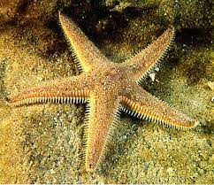
A. Asteroidea B. Echinoidea C. Octopoda D. Choriaster
38.
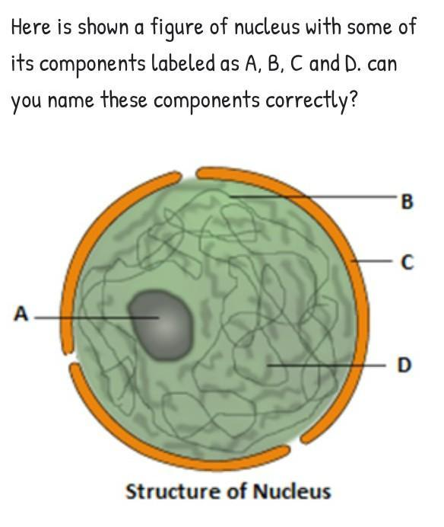
a.A -Nucleolus , B-Chromatin , C-Nuclear membrane , D -Nucleoplasm.
b.A-Chromatin ,B-Nucleolus,C-Nuclear membrane, D -Nucleoplasm
c.A-Nuclear membrane , B- Chromatin ,C-Nucleolus, D-Nucleoplasm
d.Nucleoplasm, B-Nuclear membrane , C-Chromatin ,D-Nucleolus.
39.Bacteria possess small DNA other than circular DNA which is called as
(a) Cosmid (b) Plasmid (c) Plastid (d) Starid
40. This is the largest phylum of Animals on the earth
(a) Mollusca (b) Amphibia (c) Arthropoda (d) Aves
41.The excretory organ in cockroach is
(a) green gland (b) malpighian tubules (c) nephridia (d) kidney
42.The giant redwood tree (Sequoia sempervirens) is a/an
(a) angiosperm (b) free fern (c) pteridophyte (d) gymnosperm
43.The male gametophyte in higher plants is represented by
(a) microspore (b) anther (c) pollen grain (d) male gamete
44. Which of the following groups produce seeds but lack flowers?
(a) bryophytes (b) fungi (c) pteridophytes (d) gymnosperm
45. Five kingdom system of classification suggested by R.H. Whittaker is NOT based on:
(a) Presence or absence of a well-defined nucleus
(b) Mode of reproduction
(c) Mode of nutrition
(d) Complexity of body organization
46.Which of the following statements is wrong for viroids?
(a) They lack a protein coat (b) They are smaller than viruses
(c) They cause infections (d) Their RNA is of high molecular weight
47.Insectivorous plants catch insects for obtaining
(a) Na – K (b) Taste (c) Phosphorus (d) Nitrogen
48.Who discovered mitochondriya?
A. Benda B. Kolliker C. Altman D. None of these

SECTION-C
Section-C consists of one case followed by 6 questions linked to this case (Q.No.49 to 54). Besides this, 6 more questions are given. Attempt any 10 questions in this section. The first attempted 10 questions would be evaluated
Cell is the structural and functional unit of life. Each cell is surrounded by a cell membrane which separates the internal and external environments of the cell. The interior environment of a cell is known as the cytoplasm which consists of cellular machinery and structural elements. The nucleus is present at the centre of the cell which contains all the hereditary information of an organism. Proteins, carbohydrates, sugars and starch are the organic molecules present in the cell.The chromosomes that have an additional or secondary constriction at the distal part of the arm formed by a chromatin thread are known as satellite chromosomes. These appear as an outgrowth or a small fragment. These are also known as marker chromosomes. The chromosomes 13, 14, 15, 16, 21, and 22 are satellite chromosomes.
49. A common characteristic feature of plant sieve tube cells and most of mammalian erythrocytes is
(a) Absence of mitochondria (b) Presence of cell wall
(c) Presence of haemoglobin (d) Absence of nucleus
50. Select one which is not true for ribosomes.
(a) Made of two subunits (b) Form polysome
(c) May attach to mRNA (d) Have no role in protein synthesis
51.Which one of these is not a eukaryote? .
(a) Euglena (b) Anabaena (c) Spirogyra (d) Agaricus
52. Different cells have different sizes. Arrange the following cells in an ascending order of their size. Choose the correct option among the following:
(i) Mycoplasma (ii) Ostrich eggs (iii) Human RBCs (iv) Bacteria
(a) (i), (iv), (iii), (ii) (b) (i), (iii), (iv), (ii) (c) (ii), (i), (iii), (iv) (d) (iii), (ii), (i), (iv)
53.The number of species that are known and described range between _. Fill in the blanks with the correct option from the following.

(a) 1.4 to 1.5 million (b) 1.6 to 1.7 million
(c) 1.7 to 1.8 million (d) 1.9 to 2 million
54. Identify the correct sequence of taxonomic categories
(a) species – order – kingdom – phylum
(b) order – genus – phylum – species
(c) family – species – class – genus
(d) species – genus – order – phylum
55.The excretory cells, that are found in Platyhelminthes are
(a) Nephridia (b) Coller cells (c) Flame cells (d) all above.
56.Tendons connect the following:
(a) bone to bone (b) muscle to muscle (c) cartilage to muscle (d) bone to muscle
57.identy this picture....
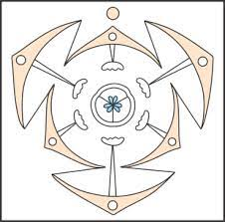
A.

C.
D.
58. It is the smallest cell
(a) Bacteria (b) Mycoplasma (c) Yeast (d) Blue-green algae
59.. In which of the following phyla, while the adult shows radial symmetry, the larva shows bilateral symmetry?
(a) Mollusca (b) Echinodermata (c) Arthropoda (d) Annelida
60. If the diploid number of a flowering plant is 36. What would be the chromosome number in its endosperm?
(a) 36 (b) 18 (c) 54 (d) 72

CLASS 11th
SUB- BIOLOGY
TERM- 1st PAPER

1- A 2- D
3- A 4- D
5- D
6- C
7- B
8- A
9- A
10- A
11- C
12- C
13- D
14- A
15- C
16- A
17- C
18- C
19- B
20- A
21- A
22- A
23- C
24- C
25- D
26- A
27- A
28- A
29- C
30- B
31- C
32- D
33- A
34- B
35- B
36- D
37- A
38- A
39- B
40- C
41- B
42- D
43- C
44- D
45- A
46- D
47- D
48- B
49- D
50- D
51- B
52- A
53- C
54- D
55- C
56- D
57- C
58- B
59- B 60- C

