KV, Banbasa NHPC
Term – I Examination
Class XI Subject Physics SET A
Session 2021 – 2022
Time: 90 Minutes
General Instructions: 1. The Question Paper contains three sections. 2. Section A has 25 questions. Attempt any 20 questions. 3. Section B has 24 questions. Attempt any 20 questions. 4. Section C has 6 questions. Attempt any 5 questions. 5. All questions carry equal marks. 6. There is no negative marking. 7. Take $g=10 \frac{m}{s^{2}}$
Section A
1 | The strongest force in the nature is
 | (i) strong nuclear | (ii) electromagnetic | (iii) gravitational | (iv) weak nuclear
2 | Which is a property of nuclear forces?
 | (i) charge dependent | (ii) distance dependent | (iii) mass dependent | (iv) none of these
3 | Which of the following is interdisciplinary?
 | (i) ray optics | (b) current and electricity | (iii) radioactivity | (iv) none of these
4 | Identify the derived unit among the following.
 | (i) Ampere | (ii) Candela | (iii) radian | (iv) Joule
5 | There are ---------------------periods of the radiation corresponding to the transition between the two hyperfine levels of the ground state of the cesium 133 atom
 | (i) 9,912,770,631 | (ii) 9,192,631.770 | (iii) 9,631,770,192 | (iv) 9,770,631,192
6 | The dimension of work is
 | (i) [M⁻¹L⁻²T²] | (ii) [M¹L²T²] | (iii) [M¹L²T⁻²] | (iv) [M²L²T²]
7 | A bus travelling between two cities is an example of
 | (i) uniform motion | (ii) non-uniform motion | (iii) circular motion | (iv) motion in a straight line
8 | Which of the following graphs represents motion at constant speed?
 | (i) 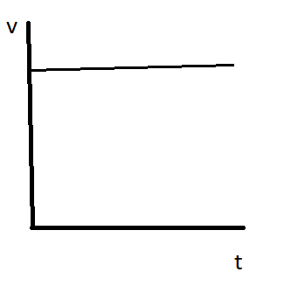 | (ii) 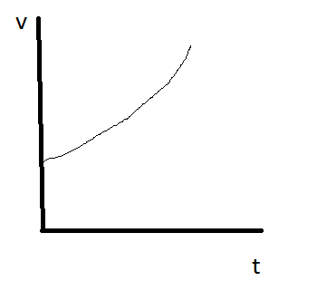 | (iii) 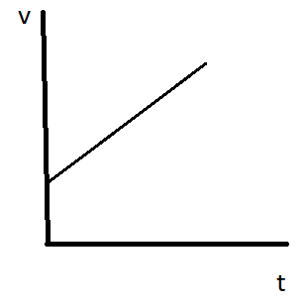 | (iv) 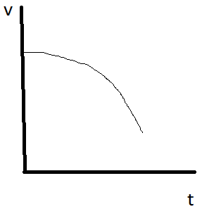
9 | The correct relationship between distance and displacement is
 | (i) distance = displacement | (ii) distance ≥ displacement | (iii) distance ≤ displacement | (iv) none of these
10 | Velocity can never be _____________ than speed.
 | (i) more | (ii) less | (iii) equal | (iv) none of these
11 | For a uniformly accelerated object, the position time graph is a
 | (i) horizontal line | (ii) vertical line | (iii) circle | (iv) a curve
12 | Which of the following position time graph is not possible?
 | (i) | (ii)  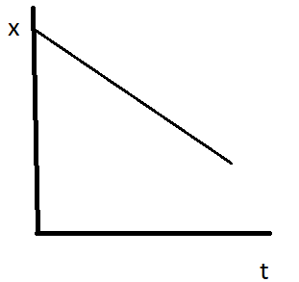 | (iii)  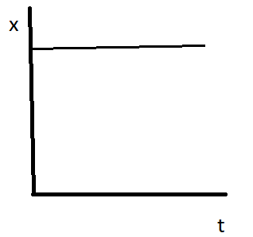 | (iv)  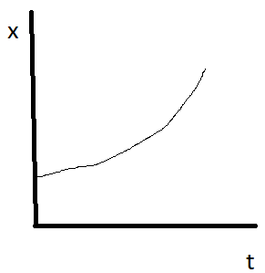
13 | Which of the following is a scalar quantity?
 | (i) current | (ii) displacement | (iii) velocity | (iv) momentum
14 | Which of the following is a vector quantity?
 | (i) current | (ii) force | (iii) energy | (iv) work
15 | The dot (scalar) product of two vectors is always a
 | (i) scalar | (ii) vector | (iii) number | (iv) none of these
16 | The cross product of two vector is always a vector that is
 | (i) parallel to each vector | (ii) perpendicular to each vector | (iii) normal to either vector | (iv) none of these
17 | Two or more vectors are called co-initial if
 | (i) have same value | (ii) have same direction | (iii) have same units | (iv) they start at same point
18 | The magnitude of a null vector is
 | (i) zero | (ii) unit | (iii) infinite | (iv) none of these
19 | When two parallel vectors are cross multiplied, the result is
 | (i) unit vector | (ii) null vector | (iii) either (i) or (ii) | (iv) none of these
20 | An object thrown at an angle with respect to the horizontal, moves over a
 | (i) circular path | (ii) straight line path | (iii) hyperbolic path | (iv) parabolic path
21 | A ball is thrown such that it attains maximum height above Earth’s surface. What is its angle of projection?
 | (i) 30⁰ | (ii) 45⁰ | (iii) 90⁰ | (iv) 60⁰
22 | The inertia of an object depends upon its
 | (i) speed | (ii) velocity | (iii) mass | (iv) momentum
23 | Force exerted on an object can change its
 | (i) speed | (ii) direction | (iii) shape | (iv) all of these
24 | The second law of motion can be expressed mathematically as
 | (i) $F=\frac{dt}{dp}$ | (ii) $F=\frac{dp}{dt}$ | (iii) $F=\frac{a}{m}$ | (iv) $F=\frac{m}{a}$

Section B
25 | Number of significant figures in 001.122310 is
 | (i) 6 | (ii) 7 | (iii) 8 | (iv) 9
26 | The time period of a simple pendulum depends upon its length (L) and acceleration due to gravity (g) such that
 | (i) $T=2π\sqrt{gL}$ | (ii) $T=2π\sqrt{\frac{L}{g}}$ | (iii) $T=2π\sqrt{\frac{g}{L}}$ | (iv) $T=2π\sqrt{\frac{L}{g2^{}}}$
27 | The unit of energy in SI and CGS system is Joule and Erg, respectively. Then
 | (i) 1 Joule = 10⁵ erg | (ii) 1 Joule = 10⁷ erg | (iii) 1 Joule = 10⁹ erg | (iv) 1 Joule = 10¹¹ erg
28 | Speed of an object is given as $v={4t}^{2}-8t$. The object would be stationary at
 | (i) t = 1 s | (ii) t = 2 s | (iii) t = 3 s | (iv) t = 4s
29 | A bus starts at station A at 8 AM and reaches station B at 9:30 AM. It stops at station B for 30 minutes and then reaches station C at 11 AM. If total distance covered is 150 km, then average speed of the bus is
 | (i) 40 km/h | (ii) 45 km/h | (iii) 50 km/h | (iv) 55 km/h
30 | The position of an object is given as $x={(2t}^{2}-4t+5) m$. Its velocity at time t = 2 s is
 | (i) 2 m/s | (ii) 4 m/s | (iii) 6 n/s | (iv) 8 n/s
31 | A ball is thrown vertically upwards with initial speed of 10 m/s. Find out its height after 1 s.
 | (i) 5 cm | (ii) 5 m | (iii) 50 cm | (iv) 50 m
32 | The area covered by v-t graph is a measure of
 | (i) distance | (ii) acceleration | (iii) velocity | (iv) energy
33 | A ball dropped from certain height is an example of
 | (i) retarded motion | (ii) accelerated motion | (iii) rotational motion | (iv) none of these
34 | The motion of an object is shown by following speed time graph. What is the distance covered by the object.  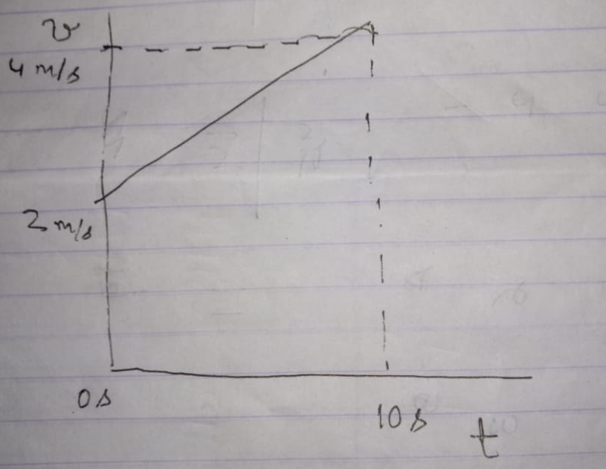
 | (i) 10 m | (ii) 20 m | (iii) 30 m | (iv) 40 m
35 | The unit vector for $A=i+2j+3k$ is
 | (i) $\frac{i+2j+3k i}{\sqrt{14}}$ | (ii) $14(i+2j+3k)$ | (iii) $\sqrt{14(i+2j+3k)}$ | (iv) $\sqrt{\frac{i+2j+3k}{14}}$
36 | A ball is thrown in such a way that its range and height are equal. Then the angle of projection is
 | (i) $\tan^{-1}(1)$ | (ii) $\tan^{-1}(2)$ | (iii) $\tan^{-1}(3)$ | (iv) $\tan^{-1}(4)$
37 | An object covers maximum horizontal distance when thrown at an angle of
 | (i) 30⁰ | (ii) 45⁰ | (iii) 60⁰ | (iv) 90⁰
38 | The dot product of $A=i+j+k$ and $B=-i-j-k$ is
 | (i) -1 unit | (ii) -3 unit | (iii) 1 unit | (iv) 3 unit
39 | The cross product of $A=i+j+k$ and $B=-i-j-k$ is
 | (i) 0 | (ii) i | (iii) j | (iv) k
40 | A ball of mass 50 g is moving with speed of 10 m/s and returns with a speed of 8 m/s after striking the wall. What is the impulse imparted to the ball?
 | (i) 0.9 kg.m/s | (ii) 1.8 kg.m/s | (iii) 0.9 g.m/s | (iv) 1.8 g.m/s
41 | A force of 12 N works at an angle of 30⁰ above horizontal direction. Its horizontal and vertical components are
 | (i) $F_{x}=6 N$  $$F_{y}=6 N$$ | (ii) $F_{x}=6\sqrt{3} N$  $$F_{y}=6\sqrt{3} N$$ | (iii) $F_{x}=6\sqrt{3} N$  $$F_{y}=6 N$$ | (iv) $F_{x}=6 N$  $$F_{y}=6\sqrt{3} N$$
42 | The angle between vector $A=i+j$and $B=i-j$ is
 | (i) 0⁰ | (ii) 90⁰ | (iii) 120⁰ | (iv) 180⁰
43 | Identify the correct relationship
 | (i) $μ_{s}>μ_{k}$ | (ii) $μ_{s}=μ_{k}$ | (iii) $μ_{k}>μ_{s}$ | (iv) none of these
44 | If a force of 40 N acts on an object of mass 100 kg, its acceleration will be
 | (i) 4 m/s² | (ii) 0.4 m/s² | (iii) 0.01 m/s² | (iv) 40 m/s²
45 | Assertion : Newton’s second law is the real law of motion  Reason : Both first and third law can be drawn from second law of motion.
 | (i) Both Assertion and Reason are correct and reason is correct explanation of assertion. | (ii) Both Assertion and Reason are correct but reason is not correct explanation of assertion. | (iii) assertion is correct but reason Is not | (iv) reason is correct but assertion is not
46 | Assertion : A person weighs much less on the Moon than on the Earth.  Reason : Newton’s third law does not hold good on the Moon.
 | i) Both Assertion and Reason are correct and reason is correct explanation of assertion. | (ii) Both Assertion and Reason are correct but reason is not correct explanation of assertion. | (iii) assertion is correct but reason Is not | (iv) reason is correct but assertion is not
47 | Assertion : Momentum of an object remains constant under application of net external force.  Reason : Internal forces can do no work due to Newton’s third law of motion.
 | i) Both Assertion and Reason are correct and reason is correct explanation of assertion. | (ii) Both Assertion and Reason are correct but reason is not correct explanation of assertion. | (iii) assertion is correct but reason Is not | (iv) reason is correct but assertion is not
48 | Assertion : If a person jumps from boat to river shore, the boat moves away from the shore.  Reason : This is due to conservation of mass.
 | i) Both Assertion and Reason are correct and reason is correct explanation of assertion. | (ii) Both Assertion and Reason are correct but reason is not correct explanation of assertion. | (iii) assertion is correct but reason Is not | (iv) reason is correct but assertion is not
49 | Assertion : Lubricants are used to increase friction.  Reason: Friction is necessary in certain cases.
 | i) Both Assertion and Reason are correct and reason is correct explanation of assertion. | (ii) Both Assertion and Reason are correct but reason is not correct explanation of assertion. | (iii) assertion is correct but reason Is not | (iv) reason is correct but assertion is not

Section C
Case Study
Friction is a dissipative force which opposes relative motion between two surfaces. Dissipative means a force where energy is converted in such a form that it cannot be recovered. It is sometime misunderstood as violation of law of conservation of energy. However, this law is not broken, neither does the law of conservation of momentum. The force of friction depends upon many factors like type of surfaces under relative motion, normal forces etc. It can be reduced by application of lubricants and increased by using cohesive materials.
50 | The force of friction
 | (i) opposes relative motion | (ii) supports relative motion | (iii) does not affect motion | (iv) none of these
51 | The force of friction can be reduced by using
 | (i) cohesive material | (ii) lubricants | (iii) it cannot be reduced | (iv) none of these
52 | Friction is an example of
 | (i) conservative force | (ii) non-conservative force | (iii) gravitational force | (iv) repulsive force
53 | Many simple approaches, like use of tyres, is used to ___________ frictional force.
 | (i) decrease | (ii) keep same | (iii) increase | (iv) none of these
54 | It is difficult to drive vehicles in desert due to _________________ friction between loose sand particles.
 | (i) infinite | (ii) high | (iii) low | (iv) zero
55 | __________________ friction is the highest value of friction.
 | (i) kinetic | (ii) static | (iii) rolling | (iv) none of these

KV, Banbasa NHPC
Term – I Examination
Class XI Subject Physics SET A Answer Key
Session 2021 – 2022

Section A
1 | (i) strong nuclear
2 | (ii) distance dependent
3 | (iii) radioactivity
4 | (iv) Joule
5 | (ii) 9,192,631.770
6 | (iii) [M¹L²T⁻²]
 |  |  |  | (iv) [M²L²T²]
7 | (ii) non-uniform motion
8 | (i)
9 | (ii) distance ≥ displacement
10 | (i) more
11 | (iv) a curve
12 | (i)
13 | (i) current
14 | (ii) force
15 | (i) scalar
16 | (ii) perpendicular to each vector
17 | (iv) they start at same point
18 | (i) zero
19 | (ii) null vector
20 | (iv) parabolic path
21 | (iii) 90⁰
22 | (iii) mass
23 | (iv) all of these
24 | (ii) $F=\frac{dp}{dt}$

Section B
25 | (ii) 7
26 | (ii) $T=2π\sqrt{\frac{L}{g}}$
27 | (ii) 1 Joule = 10⁷ erg
28 | (ii) t = 2 s
29 | (iii) 50 km/h
30 | (ii) 4 m/s
31 | (ii) 5 m
32 | (i) distance
33 | (ii) accelerated motion
34 | (iii) 30 m
35 | (i) $\frac{i+2j+3k i}{\sqrt{14}}$
36 | (iv) $\tan^{-1}\left(4\right)$
37 | (ii) 45⁰
38 | (ii) -3 unit
39 | (i) 0
40 | (i) 0.9 kg.m/s
41 | (iii) $F_{x}=6\sqrt{3} N$, $F_{y}=6 N$
42 | (ii) 90⁰
43 | (i) $μ_{s}>μ_{k}$
44 | (ii) 0.4 m/s²
45 | (i) Both Assertion and Reason are correct and reason is correct explanation of assertion
46 | (iii) assertion is correct but reason Is not
47 | (iv) reason is correct but assertion is not
48 | (iii) assertion is correct but reason Is not
49 | (iv) reason is correct but assertion is not

Section C
Case Study
50 | (i) opposes relative motion
51 | (ii) lubricants
52 | (ii) non-conservative force
53 | (iii) increase
54 | (iii) low
55 | (ii) static

