REGISTRATION FORM FOR NON-KV STUDENTS FOR ADMISSION TO CLASS XI (2022-23)
Reg No Date of Reg. (OFFICE USE)
Paste your Latest Photograph
STREAM CHOICE:
- Science

- Commerce

Subject Combinations(PLEASE TICK)
StrStream | SSSub combination(Please opt ant one from the combinations given below)
Sc SCI | 1 Hindi, English, Physics, Chemistry and Mathematics, Physical Education  2. English, Physics, Chemistry, Mathematics, Computer Science / IP , Physical Education  3. Hindi, English, Physics, Chemistry and Biology, Physical Education
COMM | 1 Hindi, English, Business Study, Accountancy and Economics, Physical Education  2. English, I.P., Business Study, Accountancy and Economics , Physical Education

- Name of applicant:
- School last Attended:

- (a) Father’s Name:
  - Occupation :
  - Basic Pay :
Mother’s Name Occupation: Basic Pay :

  - Service Category of Parent as per KVS Admission guidelines

- Residential Address:

- Phone /Mobile No Email id

- Category of Applicant (Specify Gen./ SC/ST/OBC(NCL)):

(if SC/ST/OBC(NCL), attach self-attested photocopy of certificates)

- Result of class X (supported by photo copy of mark sheet) CBSE Roll No.

Subject | Marks | Subject | Marks
Hindi |  | Mathematics Standard
Science |  | Mathematics Basic
English
Social Science |  | Total Marks with % | /500 | %
- Aggregate Marks in Science & Math

- Subject Opted Core Subject (1) English

Elective Subject (2) (3) (4) (5)

- Whether participated in SGFI/KVS National /Regional Sports Meet/Scout/Guide/NCC (if yes, please attach attested photo copies of certificate and give details). Specify the level also
We hereby declare that the above information furnished is true to the best of our knowledge.

Date: Signature of Student Parent‘s Signature

1

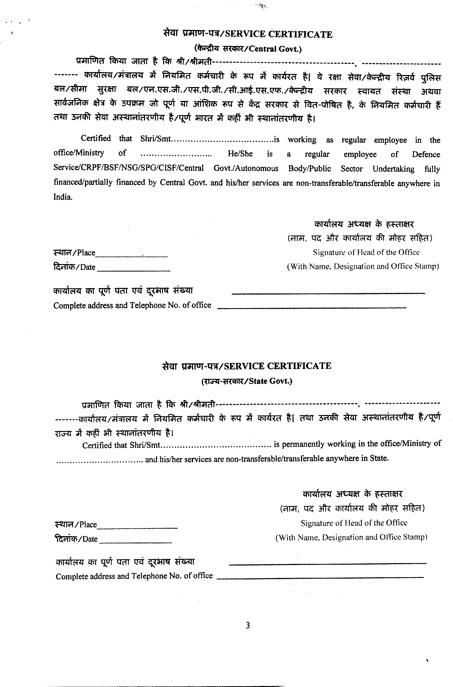
Designation

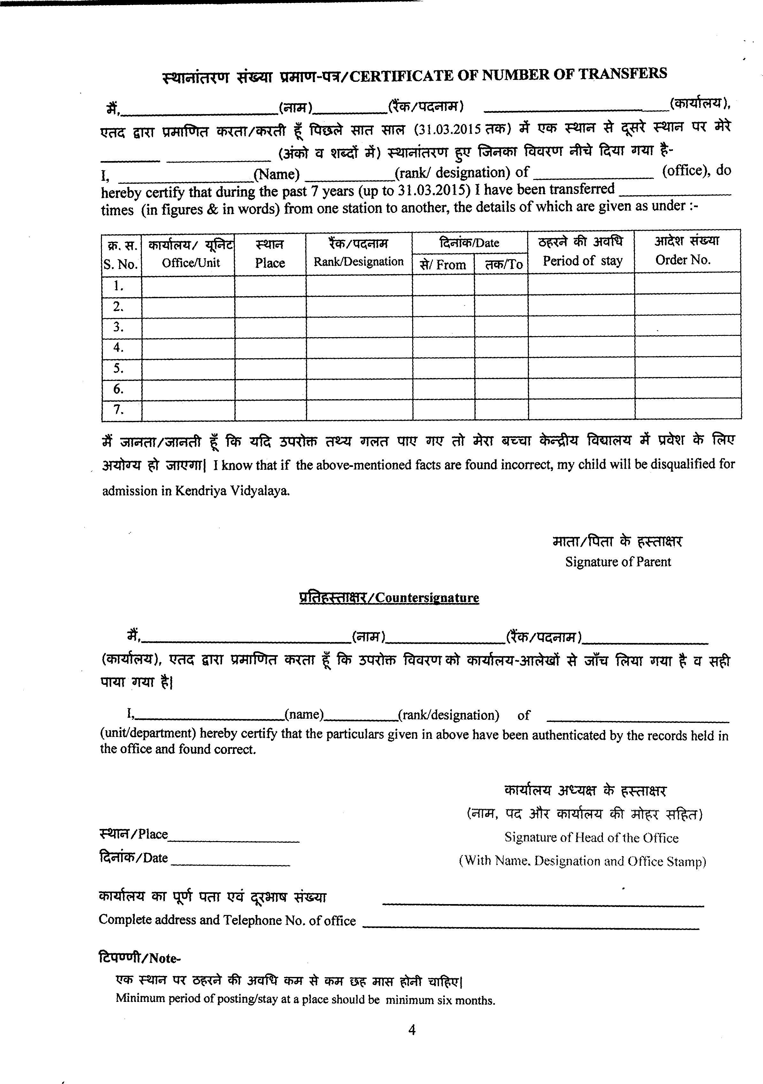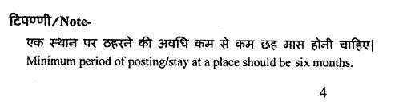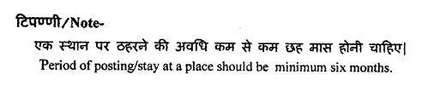

21

